# **Website Design Review - 10/06/19**

## Stage 2:

### Header:

* Nil

## Sign in:

* [To do] A confirmation email will need to be sent from [register@mywealthanalyst.com](mailto:register@mywealthanalyst.com) to the new user with a link that confirms there registration and login.

## Landing Page:

* If you re-look at the powerpoint presentation for the landing page you will see some animation and dynamics I have used which I would like replicated. You will have to enter presentation mode to see what I mean. This is particularly important for the explanation of how to use the information (John & Jane explanation).

### Live Prices:

* Can we re-order the live prices as per below:
  1. Gold
  2. Silver
  3. Bitcoin
  4. Property
  5. All Ords
  6. Oil
* The live prices don’t all display when viewing the website on a phone, see screenshot below. Suggest making the text smaller to fit.

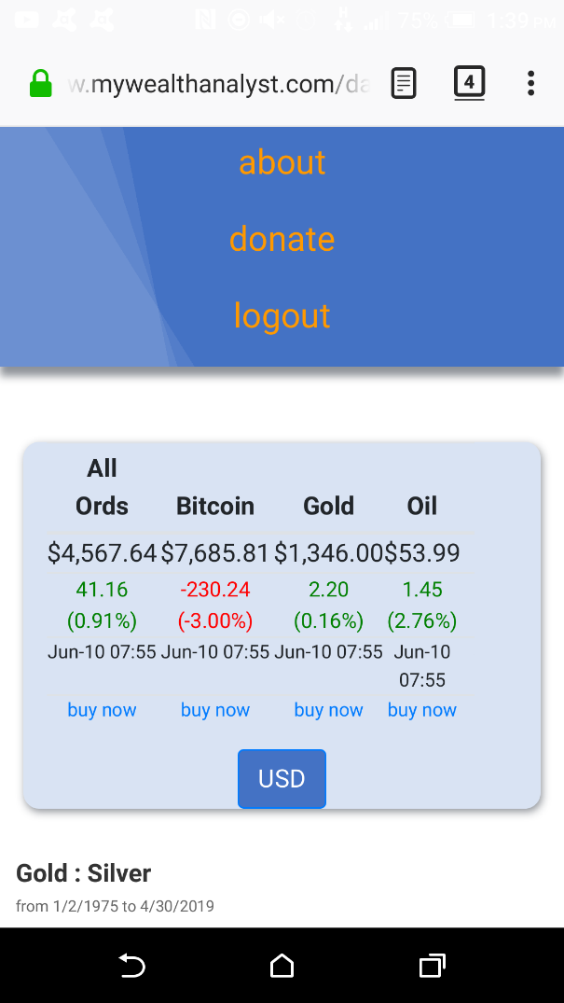

* This looks weird too

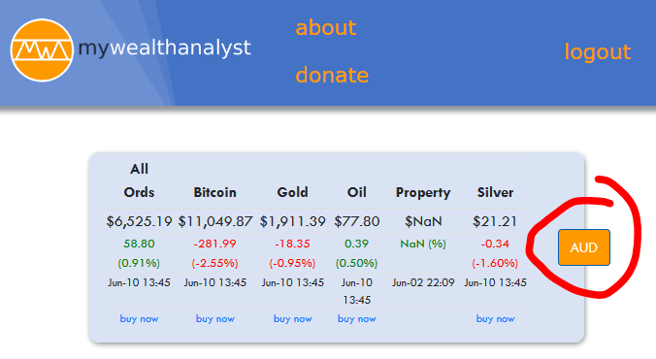

* [To do] Affiliate links - I’ll need you to set up an account and follow the instructions to get affiliate links for the mywealthanalyst website. (for example see https://www.coinbase.com/affiliates or https://www.500affiliates.com/Help/HelpPromote.aspx)

→ note – these usually require the website to be live and for the company (e.g. 500affiliates) to ‘inspect’ the website to make sure it meets their T&Cs…

→ Once you’ve set up an affiliate account, get a ‘referral link’, this link will have your unique ID so their website knows that the referral came from you (For instance: www.plus500.com/Home.aspx?id=123456, where your account id is 123456).

### Charts:

### General:

* It appears the live data is still not refreshing for the charts? Can you investigate?

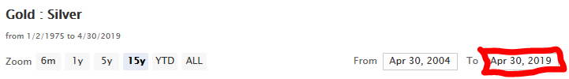

### 

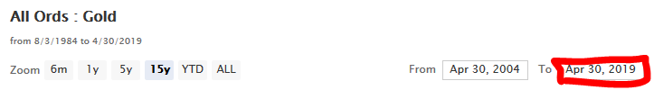

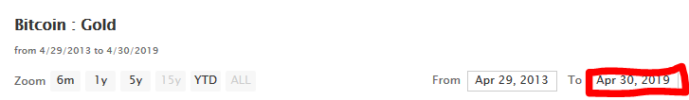

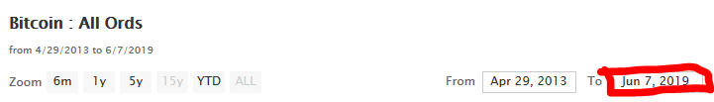

### All Ords PE Ratio

* Nil.

### All Ords:Gold

### Bitcoin:Gold

* Nil.

### Other:

* When the website is viewed on a mobile device the adds will have to be presented vertically between graphs.
* Can you please switch the placement of the contact us and Disclaimer
* Also can the copyright be centered please

